# **Business Year 11 – 12 Bridging Task**

## Subject Overview:

The OCR Business A Level consists of 3 components:

* Operating in a local business environment
* The UK business environment
* The global business environment

Content covers the following areas:

* Introduction to Business
* Objectives and strategy
* External Influences
* Accounting and Finance
* Human Resources Management
* Marketing
* Business Production.

All of the content covered could be assessed within each of the three components. Each component will have a specific focus on a type of business ranging from small/ medium enterprise to national and international firms. They will focus on a real-life business or businesses and provide stimulus material.

## Resources and Reading:

* The specification for the course is genuinely important reading – especially section 2 which tells you exactly what you will learn.

<https://www.ocr.org.uk/qualifications/as-and-a-level/business-h031-h431-from-2015/specification-at-a-glance/>

* The exam board website also has example past papers that are worth looking at to see how you will be accessed;

<https://www.ocr.org.uk/qualifications/as-and-a-level/business-h031-h431-from-2015/assessment/>

* It is recommended that all students follow the business news to gain an awareness of topical issues affecting national and multinational businesses. We recommend all students read the following websites at *least* on a weekly basis:

<https://www.tutor2u.net/business/blog> - Free online resources, theory and articles on Business Studies. Have a go at the weekly bizquiz, we will be doing this each week during term time. You are welcome to let me know your scores for any upcoming quizzes you do.

<https://blog.businesscasestudies.co.uk/> - Real life case studies. It includes business activities and theory notes.

<https://www.bbc.co.uk/news/business> - current business news stories and articles You should be regularly watching the news to keep you up to date with what is happening in business. You will be really surprised how many of the news bulletins relate to what you are studying.

* I would also recommend watching business documentaries. Some good ones are listed below:

1.[Inside the Factory](https://www.bbc.co.uk/iplayer/episodes/b07mddqk/inside-the-factory)  - BBC (many different businesses) Good for capital/ labour intensive, business sectors, added value

2.[Inside Programmes on Channel 5](https://www.channel5.com/show/inside/) - (Covers Hamleys, Harrods, Nando's & Rolls Royce amongst others)

3.Inside the Supermarket – an excellent series about Sainsbury’s. Lots of useful content.

4.Dragon's Den – BBC

5. [My5](https://www.my5.tv/browse/documentary) – excellent choice of documentaries including:- Aldi vs Lidl: Supermarket Wars, Aldi: Secrets of the Billion Dollar Discounter, British Airways: 100 years in the sky, Chocolate Dreams – Inside Hotel Chocolat ( this company was used in a previous exam paper), Henry Ford, Inside series ( includes Aldi, Lidl, Sainsbury’s Tesco, Waitrose, Legoland, Iceland, Harrods, DHL)

I would like you to be watching these regularly, at least once a week.

# **Tasks:**

Obviously, we are experiencing very turbulent times for business and the coronavirus has had a massive impact on business and the economy over the past 18 months.

I would like you to research the impact that coronavirus is having on the businesses and then using the framework below give examples of the impact it has had and how businesses have responded to it.

|  |  |  |
| --- | --- | --- |
| **PESTLE Factor** | **Examples of Impact of coronavirus and actions taken.** | **What impact does this have on businesses?**  **How might a business respond?** |
| **Political**, e.g. Government fiscal policy (Furlough scheme, Eat Out to Help Out), legislation (school & business closure) |  |  |
| **Ethical**, e.g. treatment of workers, businesses facing negative publicity for staying open, supporting good causes |  |  |
| **Social**, e.g. working from home, consumer demand for certain products |  |  |
| **Legal**, e.g. new legislation, enforcement of lockdown policy, health and safety, working from home policies |  |  |
| **Environmental**, e.g. pollution, rubbish collections, impact on farming, agriculture and plant growing. |  |  |

Complete the table below to show and explain the opportunities and threats that have arisen for businesses because of the coronavirus crisis. Include examples of businesses that have been successful and those that have suffered as a result.

|  |  |
| --- | --- |
| **Opportunities** | **Threats** |
| * Growth in online retail | * Reduction in air travel – Flybe went into administration |

|  |  |
| --- | --- |
| **Enterprise and the Entrepreneur**  By the edge of Lake Victoria, Tanzania, is a village with 2,000 people. It is poor, but has its own fishing boats, boat builder, vegetable field and (tiny) street market. The villagers work together, but individuals can keep any money they make. One villager, Pembo, noticed that – year after year – the villagers planted tomatoes in the ideal growing conditions of the rainy season. |  |

But when the tomatoes were ripe the price in the local market town was too low to make a profit. Fewer people wanted to buy them (they grew their own) and far more growers brought tomatoes to the marketplace.

In August 2008 Pembo marked out a large patch of sandy earth by the side of the lake, and sowed tomato seeds. As the rainy season was over, he had to water by hand. Every day he spent hours collecting water in a bucket from the lake and watering each plant. He marked his patch out carefully and re-planted each seedling to give it the space to grow. He tied them, tended them and eventually was able to harvest them and take them to the market. Whereas the villagers’ tomatoes usually fetched $2 per bushel, Pembo’s made $5. As he had done all the work himself, the villagers accepted that he kept all the money: this proved to be just over $100 for two months’ work (about 6 times the average income). He used the $100 to buy a second hand motorbike with a trailer.

Others in the village soon copied the method for growing tomatoes, though Pembo was already onto his next idea. He paid two 12-year-olds to look after his own patch, while he talked to a hotel in the Serengeti National Park about delivering all their fruit and vegetables.

**Questions**

1. What sort of ownership type is Pembo’s business. Explain why? (2)

2. Explain 1 advantage and 1 disadvantage of this sort of ownership type for Pembo. (2)

3. State two possible motives for Pembo’s business start-up. (2)

4. Businesses can be classified as primary sector, secondary sector or third sector.

Explain which sector(s) Pembo’s business is an example of. (2)

5. Outline two examples from the case which suggest that Pembo might prove a really successful businessman in the longer term. (4)

6. Identify 3 different stakeholders of Pembo’s business and explain what their interest in the business is. (6)

7. Comment on whether you think this business idea for out-of-season tomato-growing will continue to succeed. (4)

8. Explain how Pembo has demonstrated two entrepreneurial characteristics (4)

9. Carry out a SWOT and PESTLE analysis for Pembo’s business. (10)

Use each element of the two models as sub headings to set out your work. For each element you should be writing at least a paragraph, not a bullet point list.

Useful links; <https://www.tutor2u.net/business/reference/swot-analysis> , <https://www.tutor2u.net/business/reference/what-is-pest-analysis>

10. Choose an entrepreneur and create a business profile that could be included in a magazine / newspaper article giving an overview of the person, their business and what they have achieved.

The article must include:

1. Picture of the person
2. Business image / logo / brand
3. Background info. including; name, age, where they live, and how old they were when they set up their first business?
4. Overview of the business they created including: what the business actually does, financial performance, explanation of what makes their business successful
5. Explanation of the key enterprise skills they have demonstrated and any problems have they experienced and overcome
6. Source of where the information you have used came from

# Context in Business

Context helps us understand the nature of a business, its market and its competitive position. It helps us understand how a business makes decisions.

We can summarise the key context of any business using the acronym:

**SCORE**

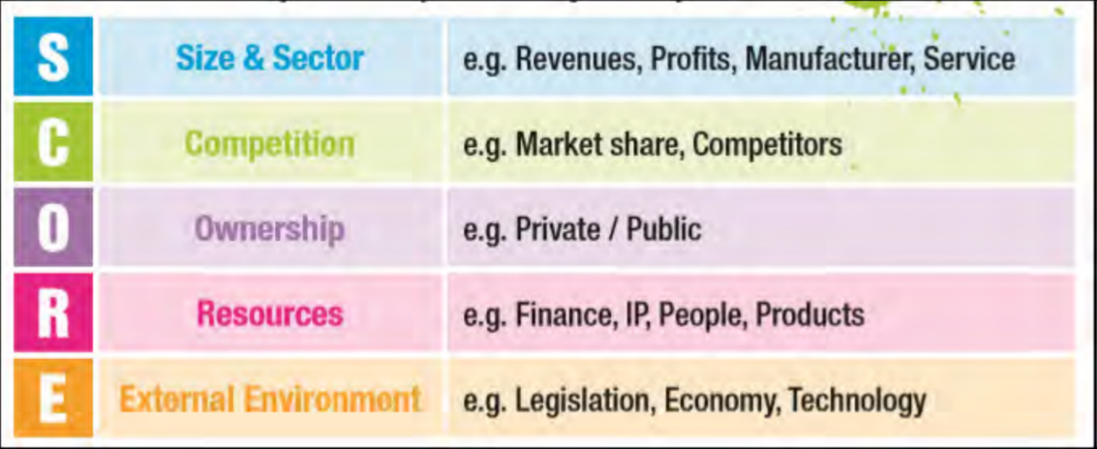

**Task**

Using the short case study on Greggs, below, identify the context for Greggs using the SCORE format:



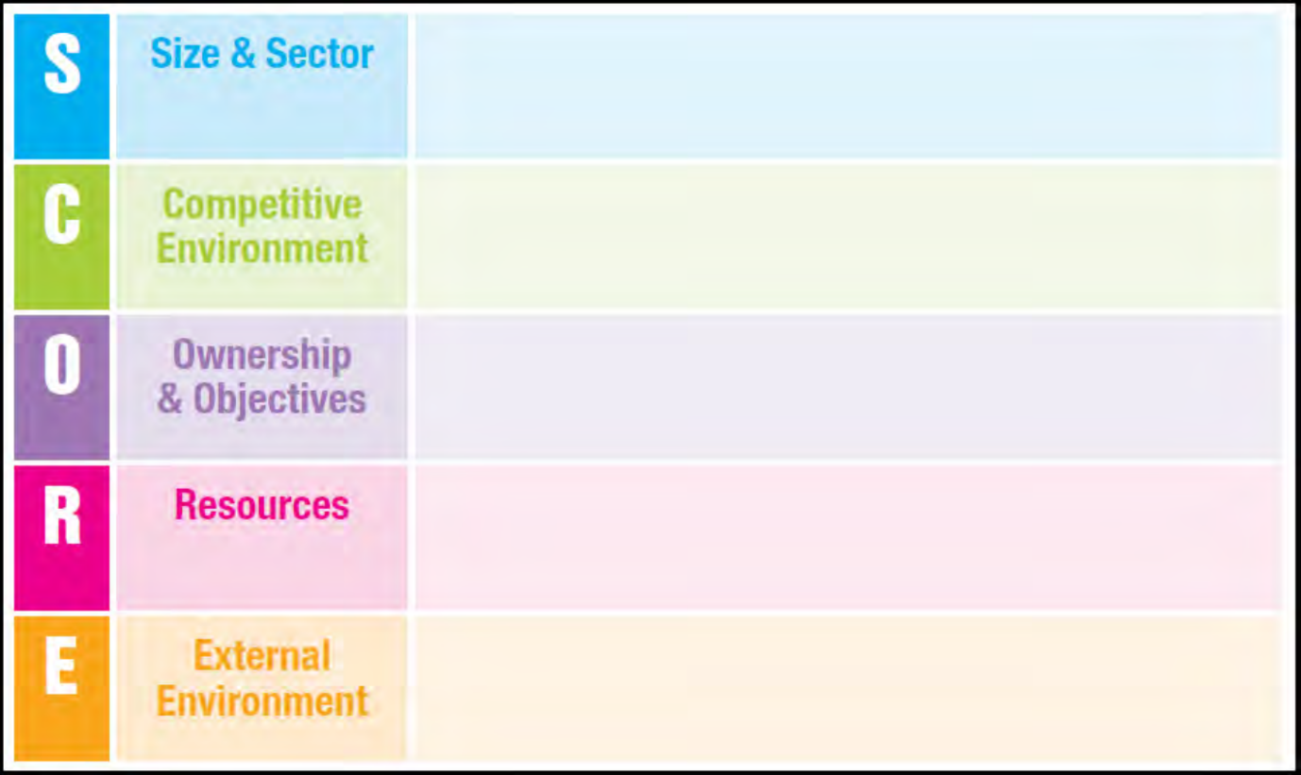

## A Level Business – Initial Numeracy Assessment – Questions

You are welcome to email me for the answers to the following questions after you have attempted them.

|  |  |
| --- | --- |
| Q1 | Balti Towers is an Indian takeaway that also offer a delivery service. Last year, the business delivered 1,400 curries. This year, the owner estimates that they will deliver 1,512 curries.  Calculate the estimated percentage increase curry deliveries. |
| ***Your workings:*** | |

|  |  |
| --- | --- |
| Q2 | School of Choc is a confectionary manufacturer located in County Durham. The business employs 120 staff. The ratio of male to female staff is 2:3.  Calculate how many female staff School of Choc employs. |
| ***Your workings:*** | |

|  |  |
| --- | --- |
| Q3 | Jimmy Chews is a sweet shop located in Wetherby. This year, the owner estimates that the business, which also sells soft drinks, will sell 3,360 cans of coca cola, 5% more than last year.  Calculate how many cans of coca cola Jimmy Chews sold last year. |
| ***Your workings:*** | |

|  |  |
| --- | --- |
| Q4 | Bubblicious is a hot tub manufacturer located in Chester. Their hot tubs retail for £4,500. The manufacturing cost per hot tub is 2/5 of the selling price.  Calculate the cost of manufacturing one hot tub. |
| ***Your workings:*** | |

|  |  |
| --- | --- |
| Q5 | The chart below shows the number of hot tubs Bubblicious sold between 2014 and 2017. The owner estimates that in 2018, hot tub sales will be 5% lower than in 2017.  Calculate the average annual sales of hot tubs between 2014 and 2018. |
| ***Your workings:*** | |

|  |  |
| --- | --- |
| Q6 | Melchester Rovers Football Club can seat 42,000 spectators. Last week, when they played Harrogate Town, there were 36,960 spectators.  Calculate the percentage of empty seats. |
| ***Your workings:*** | |

|  |  |
| --- | --- |
| Q7 | A family of four, on holiday in the UK from Spain, visited the ‘Whale of a Time’ sea life centre in London. The total entrance cost for the family was £90.  Assuming an exchange rate of £1: €1.08, calculate the total entrance cost in Euros. |
| ***Your workings:*** | |

|  |  |
| --- | --- |
| Q8 | Loft in Space, a manufacturer of loft insulation, took 80 of its employees on a two-day team building trip to an outdoor activity centre in the Lake District. The total cost of the trip was £9,600. The accommodation cost per employee was 3/5 of the total cost per employee.  Calculate the accommodation cost per employee. |
| ***Your workings:*** | |

|  |  |
| --- | --- |
| Q9 | Tea-Total is a café in Cumbria. Below is a pie chart showing the percentage of drinks purchased for a group of 200 customers.  (A) Calculate how many customers purchased a coffee  (B) Calculate how many customers did not purchase a tea  (C) Calculate the fraction of customers that purchased a Latte |
| ***Your workings:*** | |

|  |  |
| --- | --- |
| Q10 | Barber Streisand is a hair dressing salon located in Sunderland. The owner Barbara, recently introduced a new system of rewarding her staff. At the end of the week, Barbara puts the following in a bag:  5 x £10 notes  4 x £20 notes  3 x £50 notes  At the end of the week, the hairdresser who has provided the best service can select a note from the bag as a reward.  Calculate the probability of not selecting a £10 note. |
| ***Your workings:*** | |

|  |  |
| --- | --- |
| Q11 | Don Corleone owns a fish and chip restaurant, “The Codfather”   * Fixed costs are £90,000 per year * On average, variable costs are £9 per customer * On average, customers spend £27 when eating at Don’s restaurant.  1. Calculate how many customers Don needs each year in order to break even. 2. Calculate Don’s margin of safety if he serves 5,600 customers this year. |
| ***Your workings:*** | |

|  |  |
| --- | --- |
| Q12 | Daz Haagens owns an ice cream van, he knows that on a busy Saturday in the park he can sell 1500 ice cream cones. Each cone is sold for 99p. Daz also knows that his total costs for the day are £750. Calculate Daz’s total costs, revenue and profit. |
| ***Your workings:*** | |

|  |  |
| --- | --- |
| Q13 | Mr P Staker owns a small business selling computer games. He knows the variable cost to sell 100 games is £965. He has monthly fixed costs totalling £2500. In a month he sells 300 computer games. Each games sells for an average price of £20. Calculate his unit cost and profit |
| ***Your workings:*** | |

|  |  |
| --- | --- |
| Q14 | **Florist Gump**  For Valentine’s Day, Florist Gump has developed a special bouquet of flowers that they will sell for £10.00. These will be on sale during the week leading up to the day itself.  Florist Gump has a weekly rent bill of £90, an electricity bill of £20 and salaries for the week come to £500. The flowers for each bouquet cost Florist Gump £2.00, the packaging costs £0.50 and a personalised card within each bouquet costs the florist £0.10.  You should always show your working out when asked to ‘calculate’ in the exam  (a)Calculate the florist’s fixed costs for the week leading up to Valentine’s Day.  (b)Calculate each bouquet’s variable cost.  (c)The florist actually sell 120 bouquets in the week leading up to Valentine’s Day. Calculate their total costs for the week. |
| ***Your workings:*** | |