Chemistry Bridging Work – Summer 2021
As you embark upon your study of A-level chemistry, you will begin to explore the detailed structure of atoms (Topic 1). The topics that you will extend your current knowledge on over the 2-year course are outlined below.
Unit 3.1 Physical Chemistry (page 11)

- 3.1.1 Atomic structure (page 11)
- 3.1.2 Amount of substance (page 13)
- 3.1.3 Bonding (page 16)
- 3.1.4 Energetics (page 19)
- 3.1.5 Kinetics (page 20)
- 3.1.6 Chemical equilibria and Le Chatelier’s principle and Kc (page 22)
- 3.1.7 Oxidation, reduction and redox equations (page 24)
- 3.1.8 Thermodynamics (A-level only) (page 25)
- 3.1.9 Rate equations (A-level only) (page 27)
- 3.1.10 Equilibrium constant Kp for homogeneous systems (A-level only) (page 29)
- 3.1.11 Electrode potentials and electrochemical cells (A-level only) (page 30)
- 3.1.12 Acids and bases (A-level only) (page 32)

Unit 3.2 Inorganic Chemistry (page 34)

- 3.2.1 Periodicity (page 34)
- 3.2.2 Group 2, the alkaline earth metals (page 35)
- 3.2.3 Group 7(17), the halogens (page 36)
- 3.2.4 Properties of Period 3 elements and their oxides (A-level only) (page 38)
- 3.2.5 Transition metals (A-level only) (page 39)
- 3.2.6 Reactions of ions in aqueous solution (A-level only) (page 44)

3.3 Organic Chemistry (page 45)

- 3.3.1 Introduction to organic chemistry (page 45)
- 3.3.2 Alkanes (page 47)
- 3.3.3 Halogenoalkanes (page 48)
- 3.3.4 Alkenes (page 49)
- 3.3.5 Alcohols (page 51)
- 3.3.6 Organic analysis (page 53)
- 3.3.7 Optical isomerism (A-level only) (page 54)
- 3.3.8 Aldehydes and ketones (A-level only) (page 55)
- 3.3.9 Carboxylic acids and derivatives (A-level only) (page 56)
- 3.3.10 Aromatic chemistry (A-level only) (page 57)
- 3.3.11 Amines (A-level only) (page 58)
- 3.3.12 Polymers (A-level only) (page 59)
- 3.3.13 Amino acids, proteins and DNA (A-level only) (page 60)
- 3.3.14 Organic synthesis (A-level only) (page 63)
- 3.3.15 Nuclear magnetic resonance spectroscopy (A-level only) (page 64)
- 3.3.16 Chromatography (A-level only) (page 65)

If you would like to read further into the specification you can do so using this link; https://filestore.aqa.org.uk/resources/chemistry/specifications/AQA-7404-7405-SP-2015.PDF.
Throughout the A-level course you will not only develop your knowledge and understanding of chemistry but will also develop your practical, literacy and mathematical skills. To reach the highest grades at AS and A-level chemistry, you should regularly engage in wider reading around the subject to extend your knowledge beyond the specification.

Book Recommendations
This is the course book we will be using and recommend. A couple of copies are in the library to borrow as well as potentially buying second hand copies from the current Y13 or online.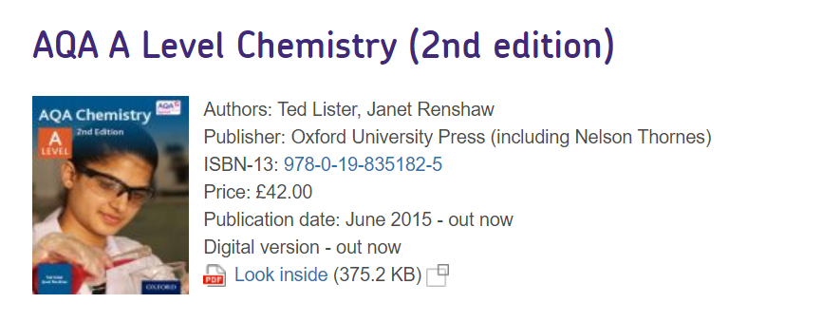
Others
There is also an accompanying revision guide and a book on practical techniques:
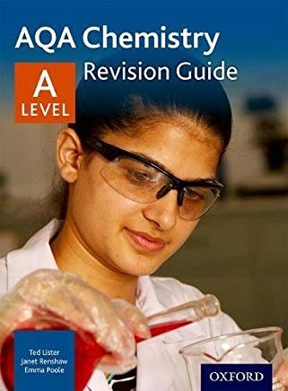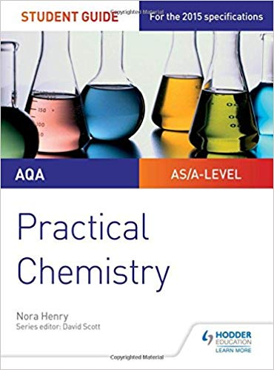
ISBN 978-0-19-835184-9 (price £14.99) ISBN 978-1-4718-8514-3 (£9.99)

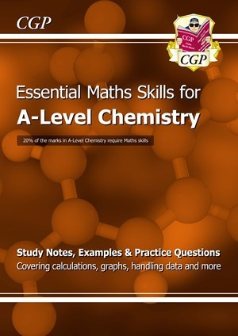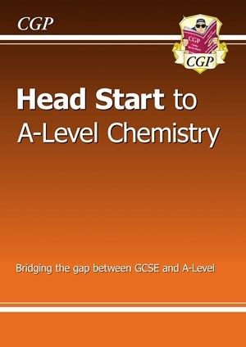
- ISBN: 9781782944720 ISBN: 9781782942801
- The CGP books could be ordered through school if you speak with the science dep’t or 6th form team.

Summer Tasks to Complete
These Chemistry bridging tasks are designed to help you to review the core principles that you learnt during your GCSE’s and to prepare yourself for the first topic that will be taught at the beginning of year 12. You must bring this work to your first Chemistry lesson in September.

- Check out mathematical requirements for the course at https://www.aqa.org.uk/subjects/science/as-and-a-level/chemistry-7404-7405/mathematical-requirements-and-exemplifications

- Complete the activities 1- 8 below.

- Watch the video “Atom 1: The Clash of the Titans” https://www.youtube.com/watch?v=Y-AiqCp7Vlc and make notes on key scientists involved and their contribution to the development of current theories. Be prepared to discuss and share these ideas during the first week in September.

- Revise key ideas on atomic structure, bonding and mole calculations and complete the tasks from the “pre-knowledge topics” below (topics 1-6).

Activity 1 Scientific vocabulary: Designing an investigation
Link each term on the left to the correct definition on the right.

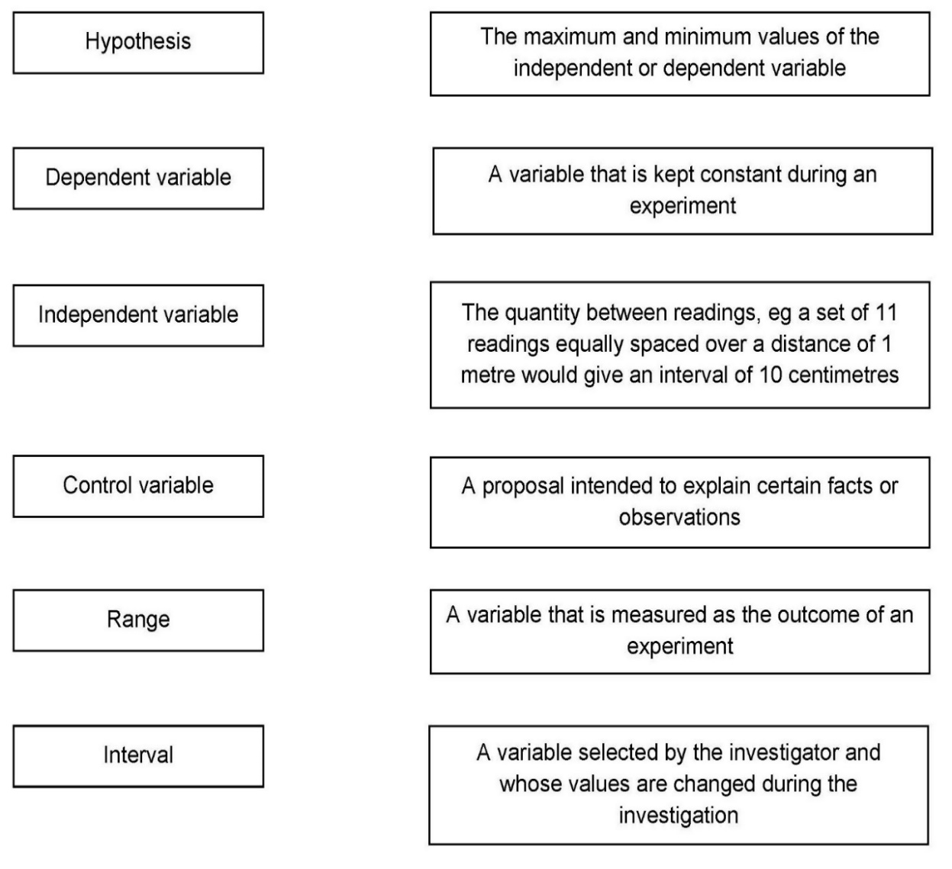
Understanding and applying the correct terms are key for practical science. Much of the vocabulary you have used at GCSE for practical work will not change but some terms are dealt with in more detail at A-level so are more complex.

Activity 2 Scientific vocabulary: Making measurements
Link each term on the left to the correct definition on the right.

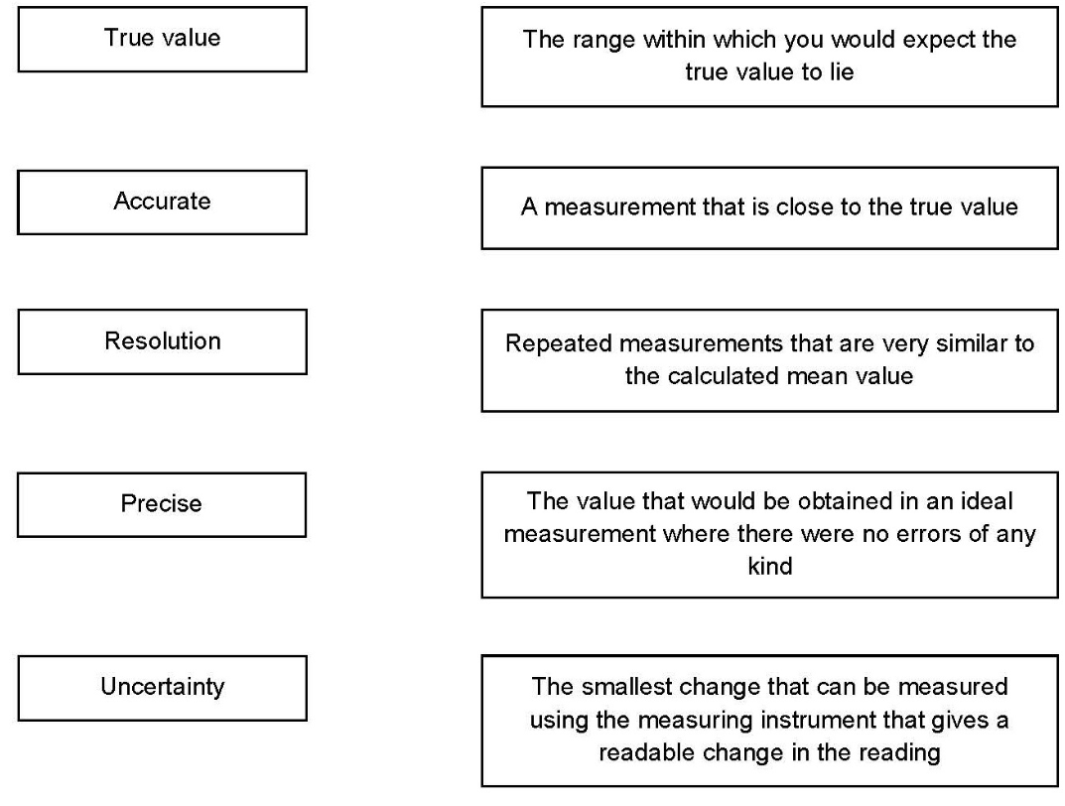

Activity 3 Scientific vocabulary: Errors
Link each term on the left to the correct definition on the right.

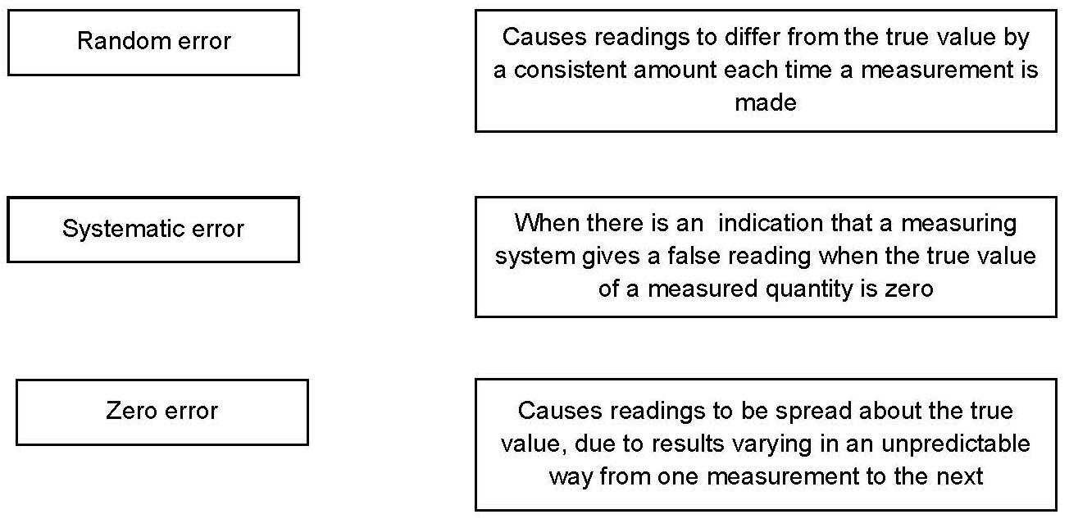

Understanding and using SI units

Every measurement has a size (eg 2.7) and a unit (eg metres or kilograms). Sometimes, there are different units available for the same type of measurement. For example, milligram, gram, kilogram and tonne are all units used for mass.

There is a standard system of units, called the SI units, which are used for most scientific purposes.

These units have all been defined by experiment so that the size of, say, a metre in the UK is the same as a metre in China.

There are seven SI base units, which are given in the table.

Physical quantity | Unit | Abbreviation
Mass | kilogram | kg
Length | metre | m
Time | second | s
Electric current | ampere | A
Temperature | kelvin | K
Amount of substance | mole | mol
luminous intensity | candela | cd

All other units can be derived from the SI base units. For example, area is measured in metres square (written as m²) and speed is measured in metres per second (written as m s^{–1}: not that this is a change from GCSE, where it would be written as m/s).

Using prefixes and powers of ten

Very large and very small numbers can be complicated to work with if written out in full with their SI unit. For example, measuring the width of a hair or the distance from Manchester to London in metres (the SI unit for length) would give numbers with a lot of zeros before or after the decimal point, which would be difficult to work with.

So, we use prefixes that multiply or divide the numbers by different powers of ten to give numbers that are easier to work with. You will be familiar with the prefixes milli (meaning 1/1000), centi (1/100), and kilo (1 × 1000) from millimetres, centimetres and kilometres.

There is a wide range of prefixes. Most of the quantities in scientific contexts will be quoted using the prefixes that are multiples of 1000. For example, we would quote a distance of 33 000 m as
33 km.

The most common prefixes you will encounter are given in the table.

Prefix | Symbol | Power of 10 | Multiplication factor
Tera | T | 10¹² | 1 000 000 000 000
Giga | G | 10⁹ | 1 000 000 000
Mega | M | 10⁶ | 1 000 000
kilo | k | 10³ | 1000
deci | d | 10⁻¹ | 0.1 | 1/10
centi | c | 10⁻² | 0.01 | 1/100
milli | m | 10⁻³ | 0.001 | 1/1000
micro | μ | 10⁻⁶ | 0.000 001 | 1/1 000 000
nano | n | 10⁻⁹ | 0.000 000 001 | 1/1 000 000 000
pico | p | 10⁻¹² | 0.000 000 000 001 | 1/1 000 000 000 000
femto | f | 10^{–15} | 0.000 000 000 000 001 | 1/1 000 000 000 000 000

Activity 4 SI units and prefixes
- What would be the most appropriate unit to use for the following measurements?

- The mass of water in a test tube.
- The volume of water in a burette.
- The time taken for a solution to change colour.
- The radius of a gold atom.
- The number of particles eg atoms in a chemical.
- The temperature of a liquid.

- Re-write the following quantities using the correct SI units.

- 0.5 litres
- 5 minutes
- 20 °C
- 70 °F
- 10 ml (millilitres)
- 5.5 tonnes
- 96.4 microlitres (µl)

- Scientists have been developing the production of a new material through the reaction of two constituents.

Before going to commercial production, the scientists must give their data in the correct SI units.

- The flow rate of the critical chemical was reported as 240 grams per minute at a temperature of 20 °C.
Re-write this flow rate using the correct SI units. Show your working.

Activity 5 Converting data
Re-write the following.

- 0.1 metres in millimetres
- 1 centimetre in millimetres
- 104 micrograms in grams
- 1.1202 kilometres in metres
- 70 decilitres in millilitres
- 70 decilitres in litres
- 10 cm³ in litres
- 2140 pascals in kilopascals

The delta symbol (Δ)

The delta symbol (Δ) is used to mean ‘change in’. You might not have seen this symbol before in your GCSE Chemistry course, although it is used in some equations in GCSE Physics.

Activity 6 Using the delta symbol
In exothermic and endothermic reactions there are energy changes.

The diagram below shows the reaction profile for the reaction between zinc and copper sulfate solution.
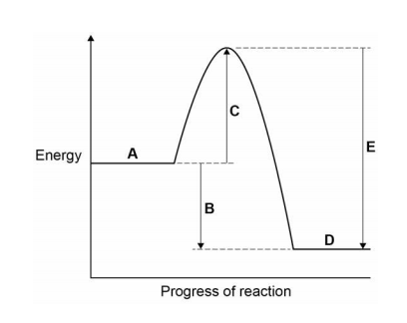

- Which letter represents the products of the reaction?

- Which letter represents the activation energy?

- Complete the sentence using the words below.
The reaction is |  | and therefore ΔH is

endothermic | exothermic | negative | positive

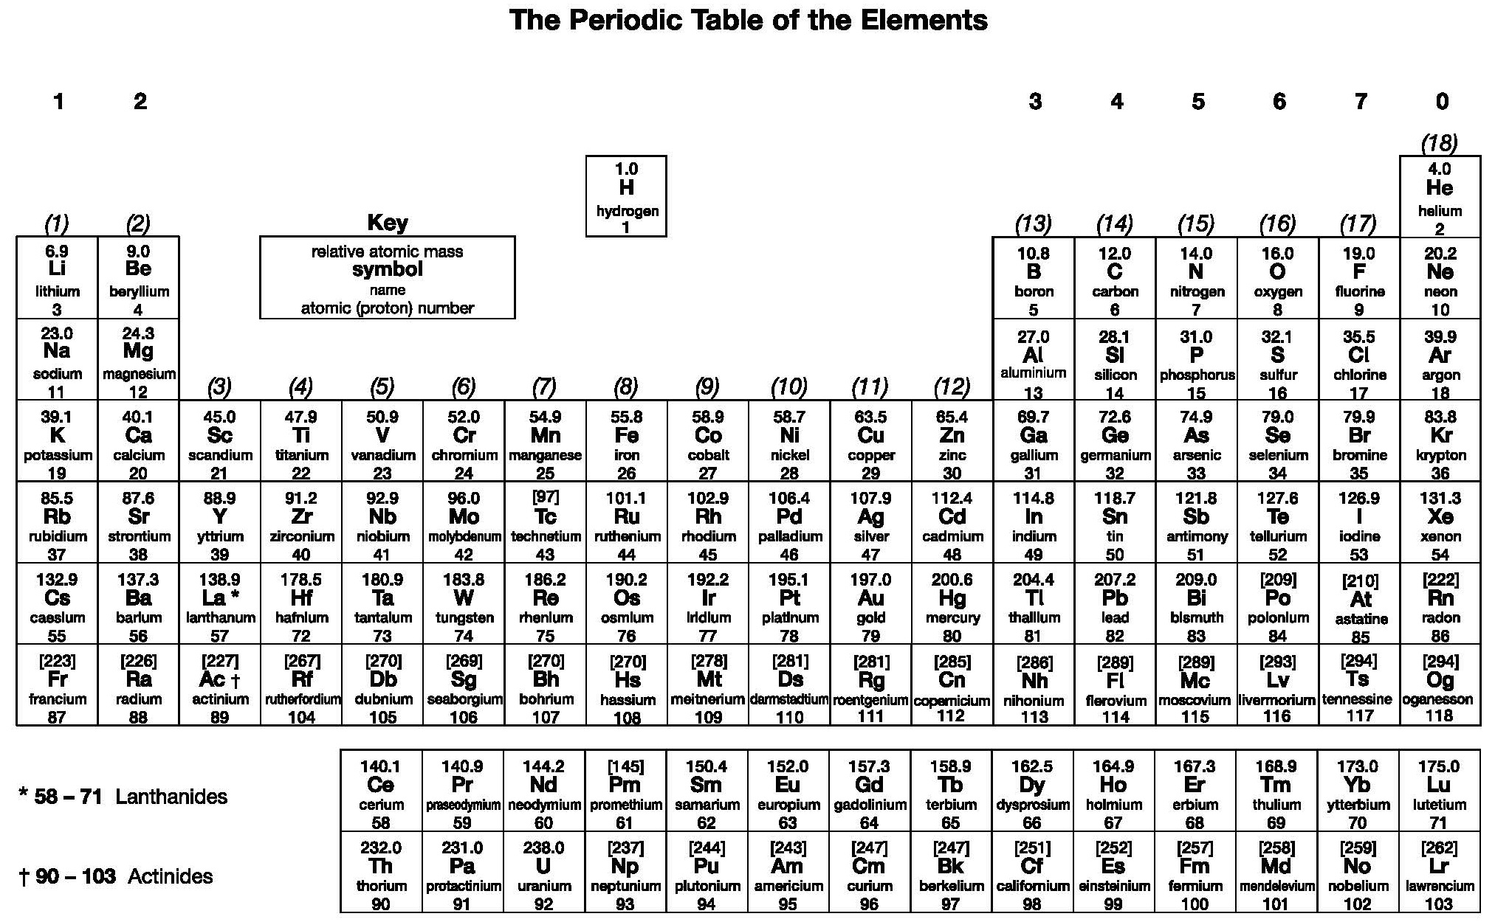

Activity 7 Atoms
- Give the atomic number of:

- Osmium
- Lead
- Sodium
- Chlorine

- Give the relative atomic mass (A_{r}) of:

- Helium
- Francium
- Barium
- Oxygen

- What is the number of neutrons in each of the following elements?
- Fluorine
- Beryllium
- Gold

Activity 8 Ions and ionic compounds
The table below lists the formulae of some common ions.

Positive ions |  | Negative ions
Name | Formula | Name | Formula
Aluminium | Al³⁺ | Bromide | Br–
Ammonium | NH₄⁺ | Carbonate | CO₃^{2–}
Barium | Ba²⁺ | Chloride | Cl–
Calcium | Ca²⁺ | Fluoride | F–
Copper(II) | Cu²⁺ | Iodide | I–
Hydrogen | H⁺ | Hydroxide | OH–
Iron(II) | Fe²⁺ | Nitrate | NO₃–
Iron(III) | Fe³⁺ | Oxide | O₂–
Lead | Pb²⁺ | Sulfate | SO₄^{2–}
Lithium | Li⁺ | Sulfide | S^{2–}
Magnesium | Mg²⁺
Potassium | K⁺
Silver | Ag⁺
Sodium | Na⁺
Zinc | Zn²⁺

Use the table to state the formulae for the following ionic compounds.

- Magnesium bromide

- Barium oxide

- Zinc chloride

- Ammonium chloride

- Ammonium carbonate

- Aluminium bromide

- Calcium nitrate

- Iron (II) sulfate

- Iron (III) sulfate

Pre-Knowledge Topics
1 – Electronic structure, how electrons are arranged around the nucleus
A periodic table can give you the proton / atomic number of an element, this also tells you how many electrons are in the atom.
You will have used the rule of electrons shell filling, where:
The first shell holds up to 2 electrons, the second up to 8, the third up to 8 and the fourth up to 18 (or you may have been told 8).
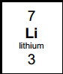
Atomic number =3, electrons = 3, arrangement 2 in the first shell and 1 in the second or
Li = 2,1
At A level you will learn that the electron structure is more complex than this, and can be used to explain a lot of the chemical properties of elements.
The ‘shells’ can be broken down into ‘orbitals’, which are given letters: ‘s’ orbitals, ‘p’ orbitals and ‘d’ orbitals.
You can read about orbitals here:
http://www.chemguide.co.uk/atoms/properties/atomorbs.html#top

Now that you are familiar with s, p and d orbitals try these problems, write your answer in the format:
1s², 2s², 2p⁶ etc.
Q1.1 Write out the electron configuration of:
a) Ca b) Al c) S d) Cl e) Ar f) Fe g) V h) Ni i) Cu j) Zn k) As
Q1.2 Extension question, can you write out the electron arrangement of the following ions:
a) K⁺ b) O²⁻ c) Zn²⁺ d) V⁵⁺ e) Co²⁺

2 – Isotopes and mass
You will remember that an isotopes are elements that have differing numbers of neutrons. Hydrogen has 3 isotopes; $H_{1}^{1}$ $H_{1}^{2}$ $H_{1}^{3}$
Isotopes occur naturally, so in a sample of an element you will have a mixture of these isotopes. We can accurately measure the amount of an isotope using a mass spectrometer. You will need to understand what a mass spectrometer is and how it works at A level. You can read about a mass spectrometer here:
http://www.kore.co.uk/tutorial.htm
http://filestore.aqa.org.uk/resources/chemistry/AQA-7404-7405-TN-MASS-SPECTROMETRY.PDF

Q2.1 What must happen to the atoms before they are accelerated in the mass spectrometer?
Q2.2 Explain why the different isotopes travel at different speeds in a mass spectrometer.
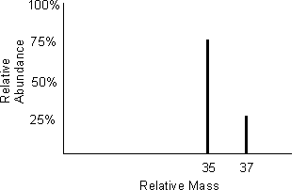
A mass spectrum for the element chlorine will give a spectrum like this:
75% of the sample consist of chlorine-35, and 25% of the sample is chlorine-37.
Given a sample of naturally occurring chlorine ¾ of it will be Cl-35 and ¼ of it is Cl-37. We can calculate what the mean mass of the sample will be:
Mean mass = (75 x 35) + (25 x 37) = 35.5
100
If you look at a periodic table this is why chlorine has an atomic mass of 35.5.
http://www.avogadro.co.uk/definitions/ar.htm
An A level periodic table has the masses of elements recorded much more accurately than at GCSE. Most elements have isotopes and these have been recorded using mass spectrometers.
GCSE A level
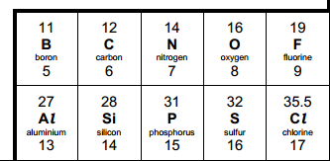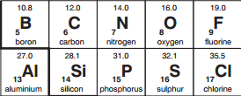
Given the percentage of each isotope you can calculate the mean mass which is the accurate atomic mass for that element.
Q2.3 Use the percentages of each isotope to calculate the accurate atomic mass of the following elements.
- Antimony has 2 isotopes: ¹²¹Sb 57.25% and ¹²³Sb 42.75%
- Gallium has 2 isotopes: ⁶⁹Ga 60.2% and ⁷¹Ga 39.8%
- Silver has 2 isotopes: 107Ag 51.35% and ¹⁰⁹Ag 48.65%
- Thallium has 2 isotopes: ²⁰³Tl 29.5% and ²⁰⁵Tl 70.5%
- Strontium has 4 isotopes: ⁸⁴Sr 0.56%, ⁸⁶Sr 9.86%, ⁸⁷Sr 7.02% and ⁸⁸Sr 82.56%
3 – Chemical equations
Balancing chemical equations is the stepping-stone to using equations to calculate masses in chemistry.
There are loads of websites that give ways of balancing equations and lots of practise in balancing.
Some of the equations to balance may involve strange chemicals, don’t worry about that, the key idea is to get balancing right.
http://www.chemteam.info/Equations/Balance-Equation.html
This website has a download; it is safe to do so:
https://phet.colorado.edu/en/simulation/balancing-chemical-equations

Q3.1 Balance the following equations

a. H₂ + 0₂ H₂0
b. S₈ + 0₂ S0₃

c. HgO Hg + 0₂

d. Zn + HCl ZnCl₂ + H₂
e. Na + H₂0 NaOH + H₂

f. C₁₀H₁₆ + CI₂ C + HCl

g. Fe + 0₂ Fe₂0₃

h. C₆H₁₂0₆ + 0₂ C0₂ + H₂0
i. Fe₂0₃ + H₂ Fe + H₂0

j. Al + FeO Al₂O₃ + Fe
4 – Measuring chemicals using relative mass and the mole
From this point on you need to be using an A level periodic table, not a GCSE one you can view one here:

https://secondaryscience4all.files.wordpress.com/2014/08/filestore_aqa_org_uk_subjects_aqa-2420-w-trb-ptds_pdf.png
Now that we have our chemical equations balanced, we need to be able to use them in order to work out masses of chemicals we need or we can produce.
The mole is the chemists equivalent of a dozen, atoms are so small that we cannot count them out individually, we weigh out chemicals.
For example: magnesium + sulfur magnesium sulfide
Mg + S MgS
We can see that one atom of magnesium will react with one atom of sulfur, if we had to weigh out the atoms we need to know how heavy each atom is.
From the periodic table: Mg = 24.3 and S = 32.1
If I weigh out exactly 24.3g of magnesium this will be 1 mole of magnesium, if we counted how many atoms were present in this mass it would be a huge number (6.02 x 10²³!!!!), if I weigh out 32.1g of sulfur then I would have 1 mole of sulfur atoms.
So 24.3g of Mg will react precisely with 32.1g of sulfur, and will make 56.4g of magnesium sulfide.
Here is a comprehensive page on measuring moles, there are a number of descriptions, videos and practice problems.
You will find the first 6 tutorials of most use here, and problem sets 1 to 3.
http://www.chemteam.info/Mole/Mole.html
Q4.1 Answer the following questions on moles.
- How many moles of phosphorus pentoxide (P₄O₁₀) are in 85.2g?
- How many moles of potassium chlorate (KClO₃) in 73.56g?
- How many moles of water are in 249.6g of hydrated copper sulfate(VI) (CuSO₄.5H₂O)? For this one, you need to be aware the dot followed by 5H₂O means that the molecule comes with 5 water molecules so these have to be counted in as part of the molecules mass.
- What is the mass of 0.125 moles of tin sulfate (SnSO₄)?
- If I have 2.4g of magnesium, how many g of oxygen (O₂) will I need to react completely with the magnesium? 2Mg +O₂ 2MgO

5 – Solutions and concentrations
In chemistry a lot of the reactions we carry out involve mixing solutions rather than solids, gases or liquids.
You will have used bottles of acids in science that have labels saying ‘Hydrochloric acid 1M’, this is a solution of hydrochloric acid where 1 mole of HCl, hydrogen chloride (a gas) has been dissolved in 1dm³ of water.
The dm³ is a cubic decimetre, it is actually 1 litre, but from this point on as an A level chemist you will use the dm³ as your volume measurement.

http://www.docbrown.info/page04/4_73calcs11msc.htm
Q5
- What is the concentration (in moldm⁻³) of 9.53g of magnesium chloride (MgCl₂) dissolved in 100cm³ of water?

- What is the concentration (in moldm⁻³) of 13.248g of lead nitrate (Pb(NO₃)₂) dissolved in 2dm³ of water?

- If I add 100cm³ of 1.00 moldm⁻³ HCl to 1.9dm³ of water, what is the molarity of the new solution?

- What mass of silver is present in 100cm³ of 1moldm⁻³ silver nitrate (AgNO₃)?

- The Dead Sea, between Jordan and Israel, contains 0.0526 moldm⁻³ of Bromide ions (Br ⁻), what mass of bromine is in 1dm³ of Dead Sea water?

6 – Titrations
One key skill in A level chemistry is the ability to carry out accurate titrations, you may well have carried out a titration at GCSE, at A level you will have to carry them out very precisely and be able to describe in detail how to carry out a titration - there will be questions on the exam paper about how to carry out practical procedures.
You can read about how to carry out a titration here, the next page in the series describes how to work out the concentration of the unknown.
https://www.bbc.co.uk/bitesize/guides/zx98pbk/revision/1

Remember for any titration calculation you need to have a balanced symbol equation; this will tell you the ratio in which the chemicals react.
E.g. a titration of an unknown sample of sulfuric acid with sodium hydroxide.
A 25.00cm³ sample of the unknown sulfuric acid was titrated with 0.100moldm⁻³ sodium hydroxide and required exactly 27.40cm³ for neutralisation. What is the concentration of the sulfuric acid?
Step 1: the equation 2NaOH + H₂SO₄ Na₂SO₄ + 2H₂O
Step 2; the ratios 2 : 1
Step 3: how many moles of sodium hydroxide 27.40cm³ = 0.0274dm³
number of moles = c x v = 0.100 x 0.0274 = 0.00274 moles
step 4: Using the ratio, how many moles of sulfuric acid
for every 2 NaOH there are 1 H₂SO₄ so, we must have 0.00274/2 =0.00137 moles of H₂SO₄
Step 5: Calculate concentration. concentration = moles/volume in dm³ = 0.00137/0.025 = 0.0548 moldm⁻³
Here are some additional problems, which are harder, ignore the questions about colour changes of indicators.

http://www.docbrown.info/page06/Mtestsnotes/ExtraVolCalcs1.htm
Use the steps on the last page to help you
Q6.1 A solution of barium nitrate will react with a solution of sodium sulfate to produce a precipitate of barium sulfate.
Ba(NO₃)₂(aq) + Na₂SO₄(aq) BaSO₄(s) + 2NaNO₃(aq)
What volume of 0.25moldm⁻³sodium sulfate solution would be needed to precipitate all of the barium from 12.5cm³ of 0.15 moldm⁻³ barium nitrate?

