Introduction to
A level
Sociology
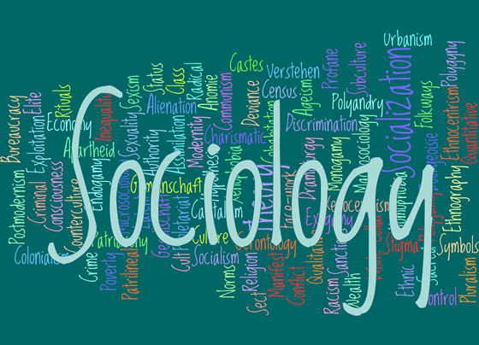

As part of your bridging programme we would like you to cover a general introduction to A level Sociology – this is a very useful exercise for both students who have and haven’t studied the subject before. The notes produced in the booklet will be discussed in the first few lessons at the start of year 12. You should use the information and links in this booklet to answer the question as well the ‘Introduction to Sociology’ PowerPoint that has also been provided.
What is culture?
Why do sociologists believe that we are a product of our environment? Use the information on ‘feral children to help you to example this.
………………………………………………………………………………………………………………………………………………………………………………………………………………………………………………………………………………………………………………………………………………………………………………………………………………………………………………………………………………………………………………………………………………………………………………………………………………………………………………………………………………………………………………………………………………………………………………………………………………………………………………………………………………………………
What is culture?
Definition –

concept | definition | example
Meanings

Norms

Values

Customs

Roles

What is a subculture?

Watch the ‘Mods and Rockers Rebooted BBC Documentary 2014’
https://www.youtube.com/watch?v=rFL54R9g5Io
In the space below – describe some of the features of the ‘Mod’ youth subculture of the mid 196o’s

Cultural Diversity
Watch the video clip from HSBC and discuss on you table what is meant by Cultural diversity. In the space below, write a definition of cultural diversity and give examples around the oval.
http://www.discoversociology.co.uk/introductiontosociology/culture-1

Cultural diversity is -

What is Socialisation?

Primary socialisation is

An example is –

Secondary socialisation is

An example is -

Identity is again another extremely complex and debated term. Put simply, identity refers to our sense of ‘self’, or ‘who we are’. It is about how we define who we are. Where our sense of identity comes from relates, closely to debates of structure and agency. This means, to what degree is ‘who we are’ determined by social structures? That is to say, our identities are largely set by social structures, like our gender or ethnicity, and the class we are born into. Or, to what extent, identity shaped by the personal choices we make, which we refer to as agency.
It is also important for recognise that our identity is not just one thing, which is set and unchangeable. We all play out different roles, in society, and hence people will see us in a different light in different settings. Also, ‘who we are?’ is something that is constantly changing over time.

How does socialisation help to form our identity? – This is an important question in A-level Sociology, as is the term identity. In the space below answer this question and define the term identity.

Agencies of social control
Think about how the different agencies of social control listed below help to socialise us into society – then fill in the spaces with your ideas.

Parents / family | Schools
Peer group | Mass Media
Religion | Work – stretch and challenge

Roles
What are roles and give an example?
………………………………………………………………………………………………………………………………………………………………………………………………………………………………………………………………………………………………………………………………………………………………………………………………………………………………………………
What are role models and give an example?
………………………………………………………………………………………………………………………………………………………………………………………………………………………………………………………………………………………………………………………………………………………………………………………………………………………………………………
What is role conflict and give an example of how this may occur?
………………………………………………………………………………………………………………………………………………………………………………………………………………………………………………………………………………………………………………………………………………………………………………………………………………………………………………

Read the article below - what does it tell us about women and role conflict?
This article represents the findings of a study undertaken at a commercial banking group to determine the nature and extent of role conflict experienced by women personnel. The rationale behind the study was that women, because they have to fulfil multiple roles in society, are at risk of experiencing conflict among their different roles. Role conflict among women can have a negative effect on their functioning as employees and should therefore be addressed by the employer, in this case the commercial banking sector. Various factors that might Influence the nature and extent of role conflict among working women were identified. These factors were operationalised in a self-administered questionnaire. Identified factors included marital relationship, the life cycle of the family and the presence of traditional values. A further goal of the study was to determine the extent to which the particular banking group was implementing women-friendly practices and to what extent this influenced female personnel's experience of role conflict.
However, the findings of this study indicated that women do not experience acute role conflict between their worker role and their other significant roles, such as those of mother and spouse. What emerged was that women viewed themselves as equal to their male counterparts in the workplace, although they were not treated that way by the personnel structure. Gender discrimination is more an area of concern to these women than role conflict.

………………………………………………………………………………………………………………………………………………………………………………………………………………………………………………………………………………………………………………………………………………………………………………………………………………………………………………………………………………………………………………………………………………………………………………………………………………………………………………………………………………………………………………………………………………………………………………………………………………………………………………………………………………………………
Social control
Social control –
………………………………………………………………………………………………………………………………………………………………………………………………………………………………………………………………………………………………………………………………………………………………………………………………………………………………………………
What are positive and negative sanctions and give examples of how they help social control.
………………………………………………………………………………………………………………………………………………………………………………………………………………………………………………………………………………………………………………………………………………………………………………………………………………………………………………………………………………………………………………………………………………………………………………………………………………………………………………………………………………………………………………………………………………………………………………………………………………………………………………………………………………………………

