**A Level Induction Test (Non-calculator)**

**Example Test**

**You may NOT use a calculator**

If *ax*2 + *bx* + *c* = 0 then *x* **= **

1. Expand and simplify

(a) (2*x* - 3)(2*x* – 1) **(2)** (b) (*x* -2)2 **(2)** (c) 4*x*(*x+*3) – 2*x*(5*x* - 1) **(2)**

2. Factorise

(a) 14*x*2 + 21*x* **(2)** (b) 9*y*2 – 49 **(2)** (c) *x*2 + 5*x* – 36 **(2)** (d) 6*t*2 + *t* -2 **(2)**

3. Simplify

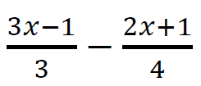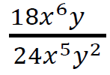 (a)  **(2)** (b) **(2)**

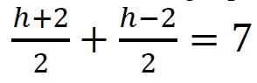4. Solve the following equations

(a) **(3)** (b) 4*x*2 – 9*x* = 0 **(3)** (c) *p*2 + *p* = 12 **(3)**

5. Write each of the following as single powers of *x* and / y

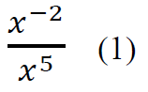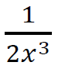

(a) **(1)** (b) (3*x*4)3 **(1)** (c)

6. Work out the values of the following, giving your answers as fractions

(a) 2-5 **(1)** (b) **(1)** (c)  **(2)**

7. Solve the simultaneous equations 6*x* + 4y = 10

5*x* + 6y = 11 **(3)**

8. Rearrange the following equations to make *x* the subject

(a) *s* = u2 + *xt*  **(2)** (b) V = π*x*2 **(2)** (c) y = **(3)**

9. Solve 5*x*2 + 10*x* + 2 = 0 giving your solutions in surd form **(3)**

10. Simplify

1. **(1)** (b) **(2)** (c) **(2)**

11. Solve tan x = 0.9 for 0 ≤ x ≤ 360. Give answers to nearest 0.1° **(2)**

12. Given that sin x = $\frac{3}{5}$ find the exact values of tan x and cos x **(3)**

13. Sketch (do not plot) these graphs showing any points of intersection with the x and y axes.

1. y = 3x + 4 **(3)** (b) 2x + 3y = 12 **(3)** (c) y = x² + 5x + 4 **(3)**