Computer Science Year 11 – 12 Bridging Task

Subject Overview:
The OCR Computer Science A Level consists of three main components:
- Unit 1 – Computer Systems
- Unit 2 – Algorithms and Programming
- Unit 3 – Programming Project
Unit 1 covers the in depth theory of computer systems, their components and how they work. You will learn how programs are made, how computers translate and understand them, how computers are controlled, Boolean algebra and mathematics and a wide range of moral, cultural and social impacts of current and future technology.
In unit 2 you will learn how to decompose real world problems into their component parts and how to construct a sensible solution to a problem using standard algorithms. This unit also covers how we measure the efficiency of systems and algorithms and prepares you with the necessary skills to undertake the coursework task.
Unit 3 allows you to carry out any programming task of your own choosing. You are then given a 6 month window in which to plan, design and implement your program/system.
Resources and Reading:
- The specification for the course is genuinely important reading – especially section 2 which tells you exactly what you will learn and Appendix 5 which gives you examples of code we will be using and you need to know.

https://www.ocr.org.uk/qualifications/as-and-a-level/computer-science-h046-h446-from-2015/

- We have a revision website that is in continuous development and currently contains all of our lesson resources:

www.learnitwithdavo.co.uk

- You need to keep up with IT news and current affairs as this will form a large number of marks in long answer questions based around ethics, moral and cultural issues. We recommend all students read the following websites at least on a weekly basis:
www.slashdot.org
www.theregister.co.uk

Further reading:
- The Design of Every Day Things by Don Norman is a seminal book in computing and design – he worked for many years as a design lead at Apple and is responsible for some of the most intuitive designs/systems we use today. His book can be found online at:

http://www.nixdell.com/classes/HCI-and-Design-Spring-2017/The-Design-of-Everyday-Things-Revised-and-Expanded-Edition.pdf

- Ghost in the Wires by Kevin Mitnick is an intriguing real-life account of identity fraud, security research and other relevant topics to our course. This can be found on Amazon.

Tasks:
Task 1 – Truth tables
Given the circuit below, create and complete the truth table:
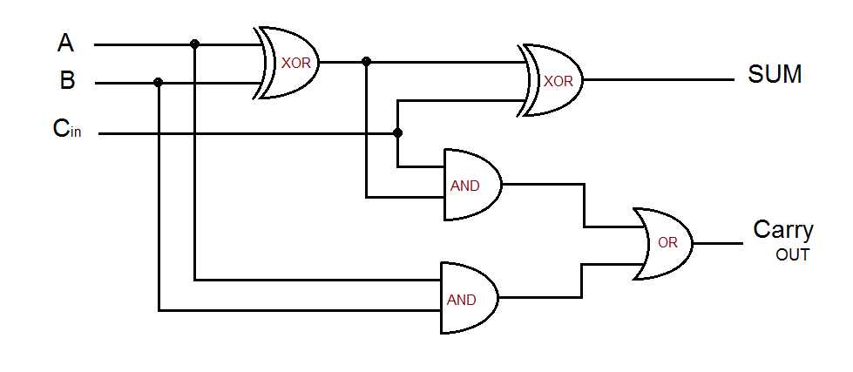
Task 2 – Decomposition
NASA are developing a new Mars Rover robot. The development of such machines costs millions of dollars and they simply cannot afford to lose or destroy the rover once it is launched. To reduce development costs and train astronauts and scientists in its use, they decide to develop a computer based simulation of the rover. The system will enable users to get used to the controls, how it responds to input and the behaviour of the craft in a “real world” situation.
- Abstract the problem – make two lists titled “Essential components” and “unnecessary components.” Under each, make a decision about what things you would consider must be developed in this simulation and what would be irrelevant – for example the number of stars visible in the sky would not be relevant to this simulation and therefore we would not add this to our simulation.
- Decompose the problem – make a list of what you would consider are the main tasks that would need to be carried out in order to create this simulation. For example, one task may be “implement appropriate gravity”
Task 3 – Programming
Using any language of your choice, write a simple program which attempts to predict the outcome of a Formula One race. This can be as simplistic or complicated as you like, but as a guide it should at least consider some prior performance, qualifying positions and perhaps time differences. There should be some “reasonable” maths used to form the prediction. In other words it is not sufficient to say “first place in qualifying will win!”

